**Project Title**

**A Data-Driven Analysis of Customer Behaviour and Purchase Drivers**

**Business Problem**

The core problem is the *lack of granular understanding* of which customer segments are most valuable, what specific product features (Category, Size, Color, Season) drive higher spending and positive feedback, and which operational factors (Shipping Type, Discount Applied, Payment Method) are influencing the frequency and amount of purchases.

**Project Deliverables**

The goal of these deliverables is to translate the raw data and analysis into **actionable business intelligence** for the stakeholders (Marketing, Sales, and Operations teams).

1. Data Preparation and Profiling Report - The final, processed CSV or Excel file ready for analysis. All null values handled, data types correctly assigned and categorical variables encoded if necessary.
2. Key Segment and Purchase Driver Analysis - A summary identifying customers who score high on Frequency of Purchases and Previous Purchases, and spend the most (Purchase Amount (USD)).
3. Operational and Experience Optimization Recommendations - Comparative summary of Purchase Amount and Frequency of Purchases across different Payment Method groups. A visualization comparing the average Previous Purchases and Purchase Amount of customers with a Subscription Status of 'Yes' vs. 'No', providing a clear justification for increasing subscription-based marketing efforts.
4. Final Presentation and Interactive Dashboard - A presentation summarizing the business problem, the analytical approach, the key findings from Deliverables. A dynamic dashboard built in a tool like Power BI, allowing stakeholders to filter and explore data by Category, Location, and Subscription Status to answer ad-hoc questions.

***Data Preparation using Python Libraries***

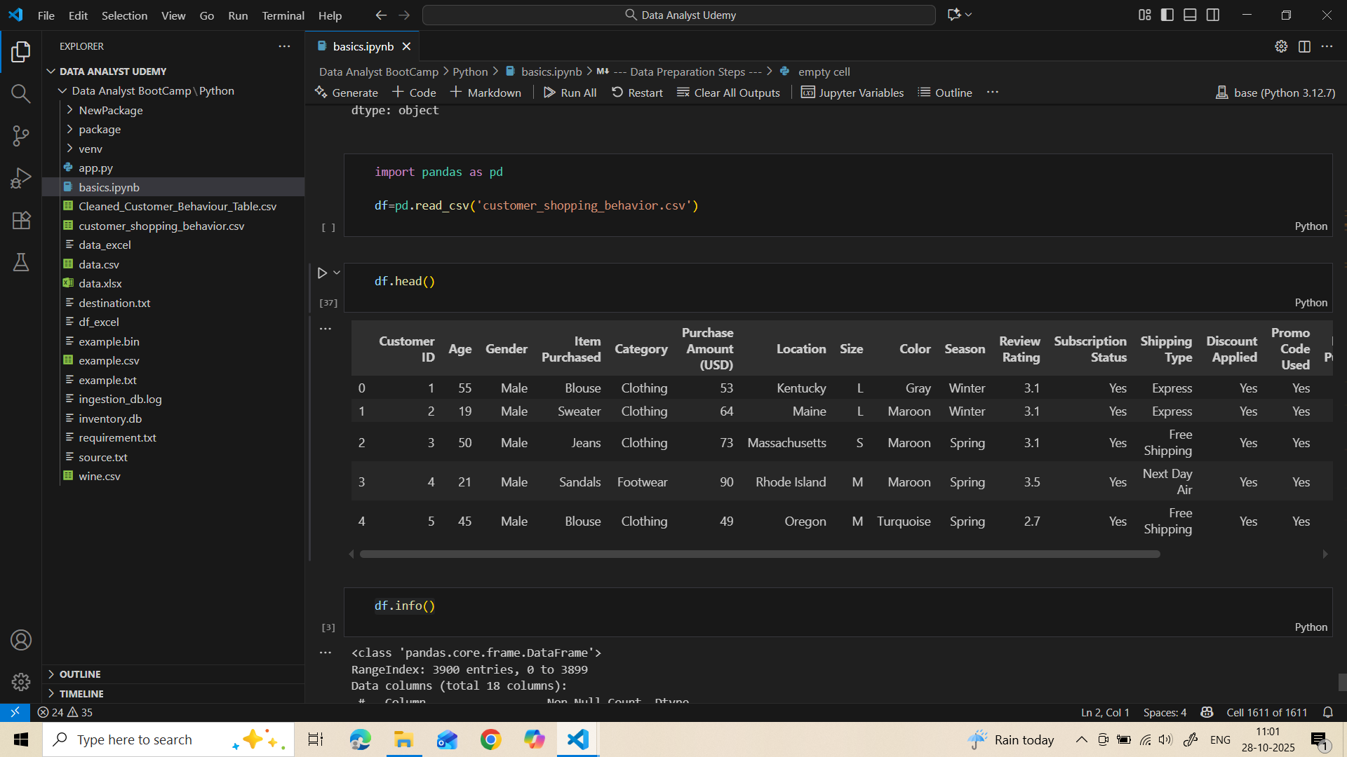

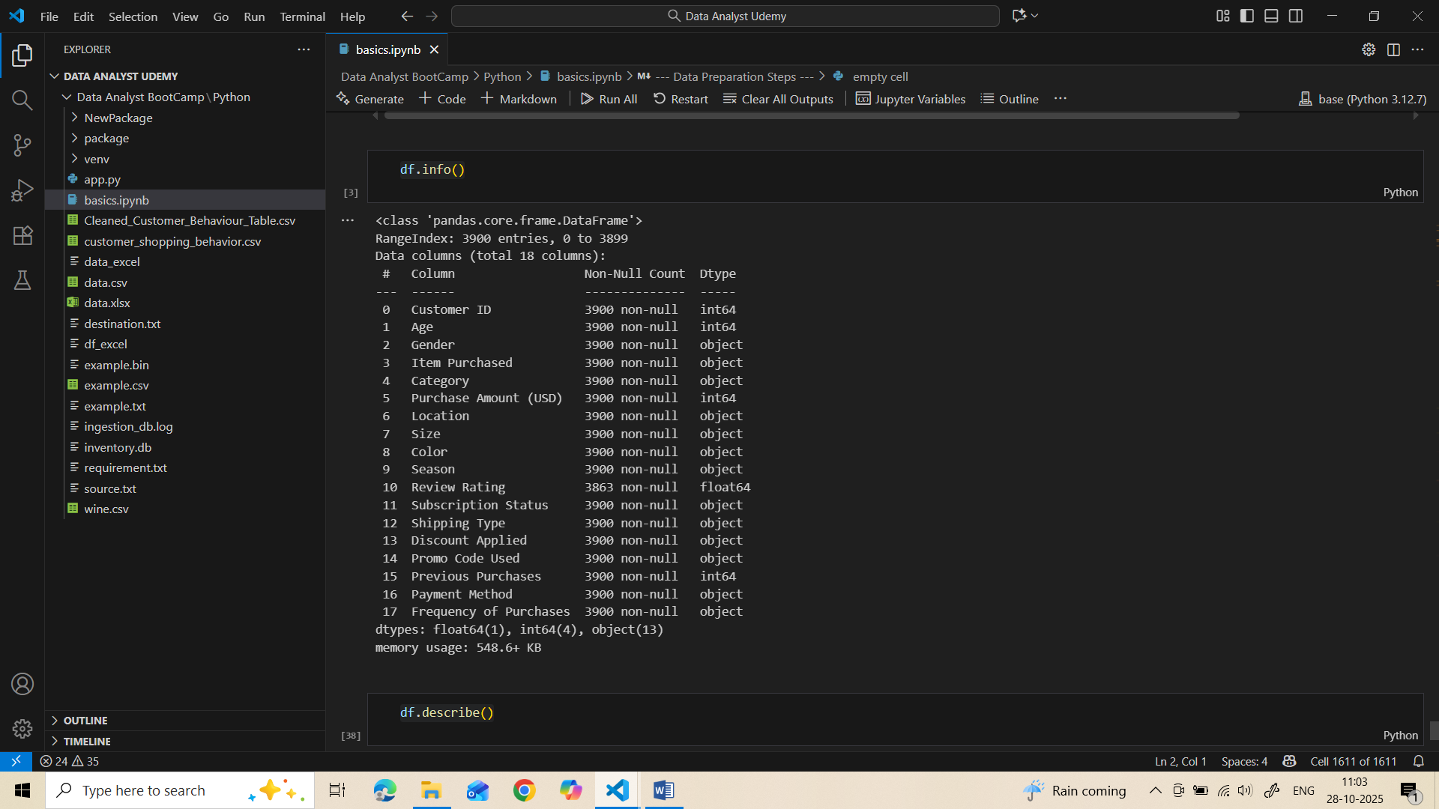

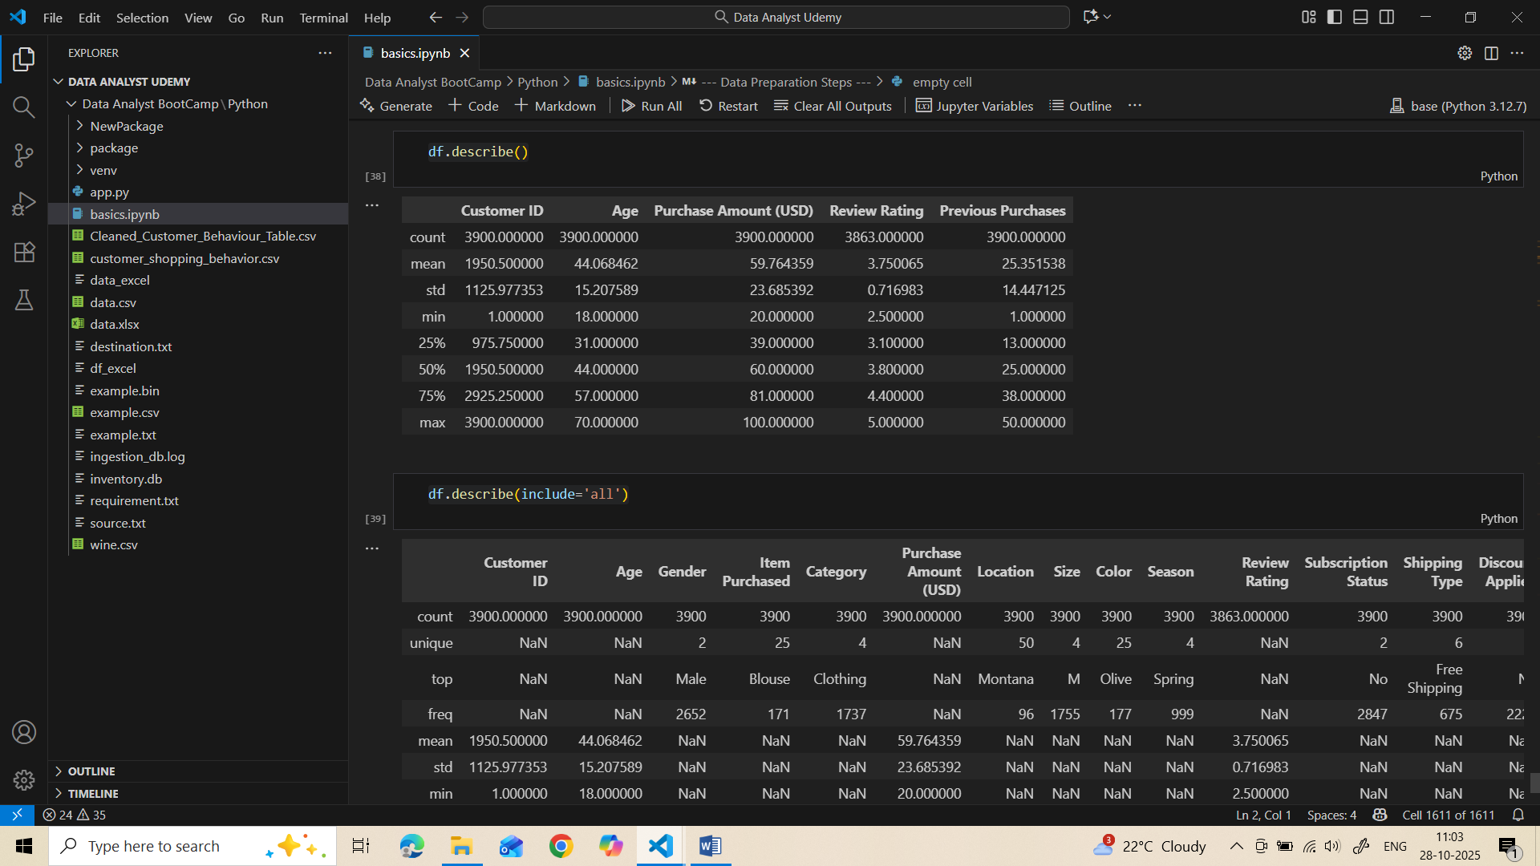

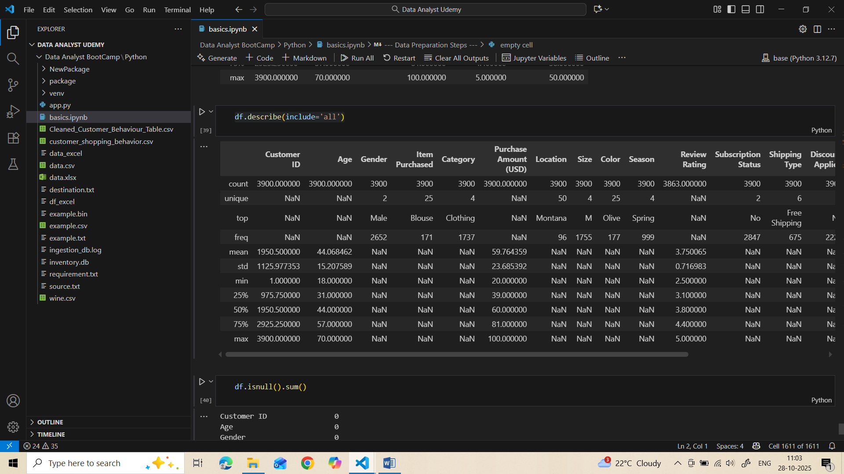

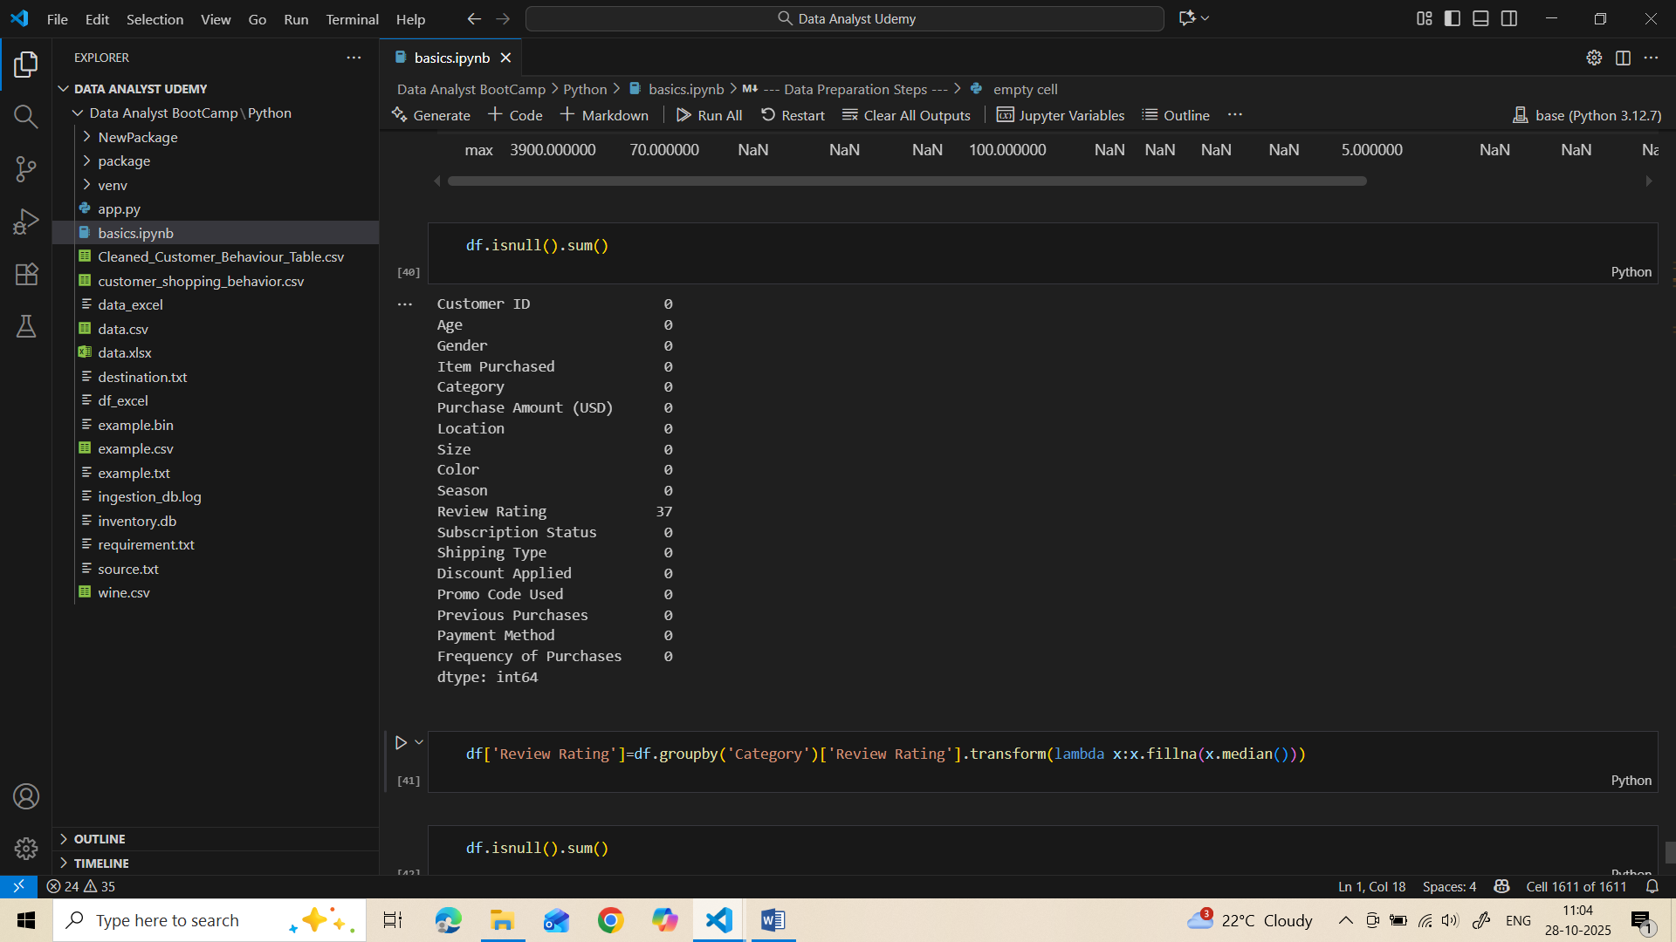

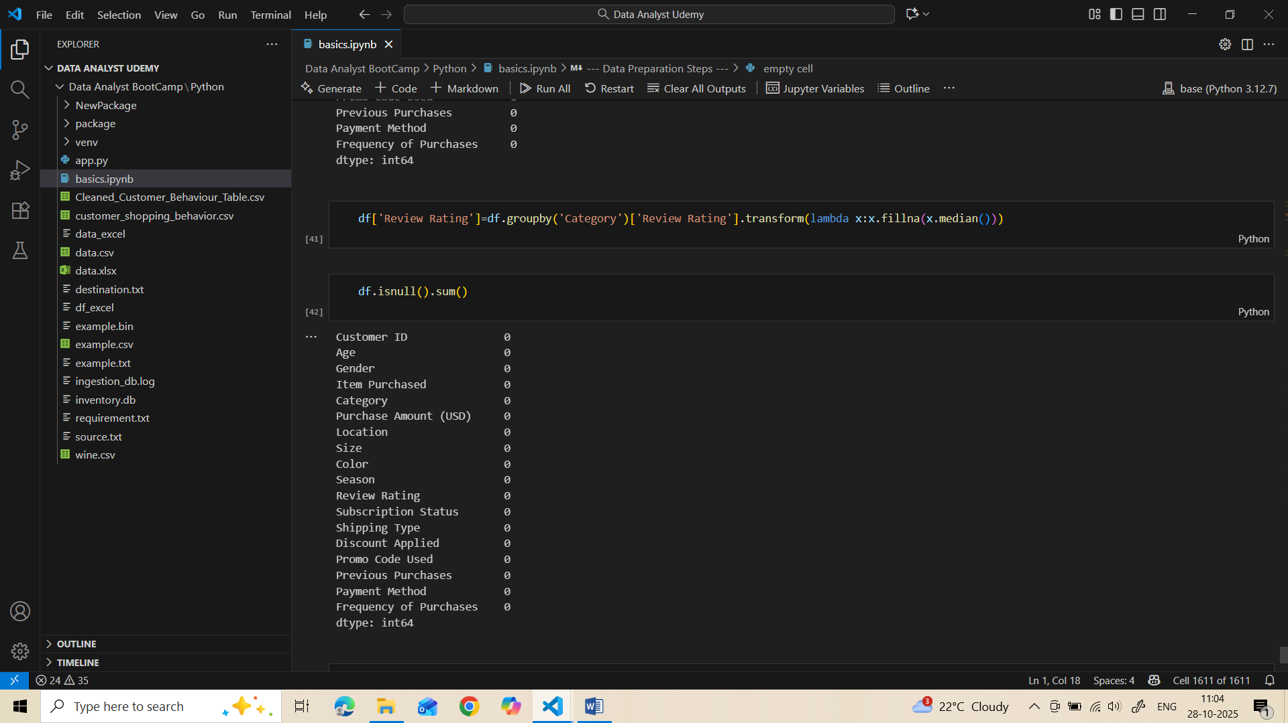

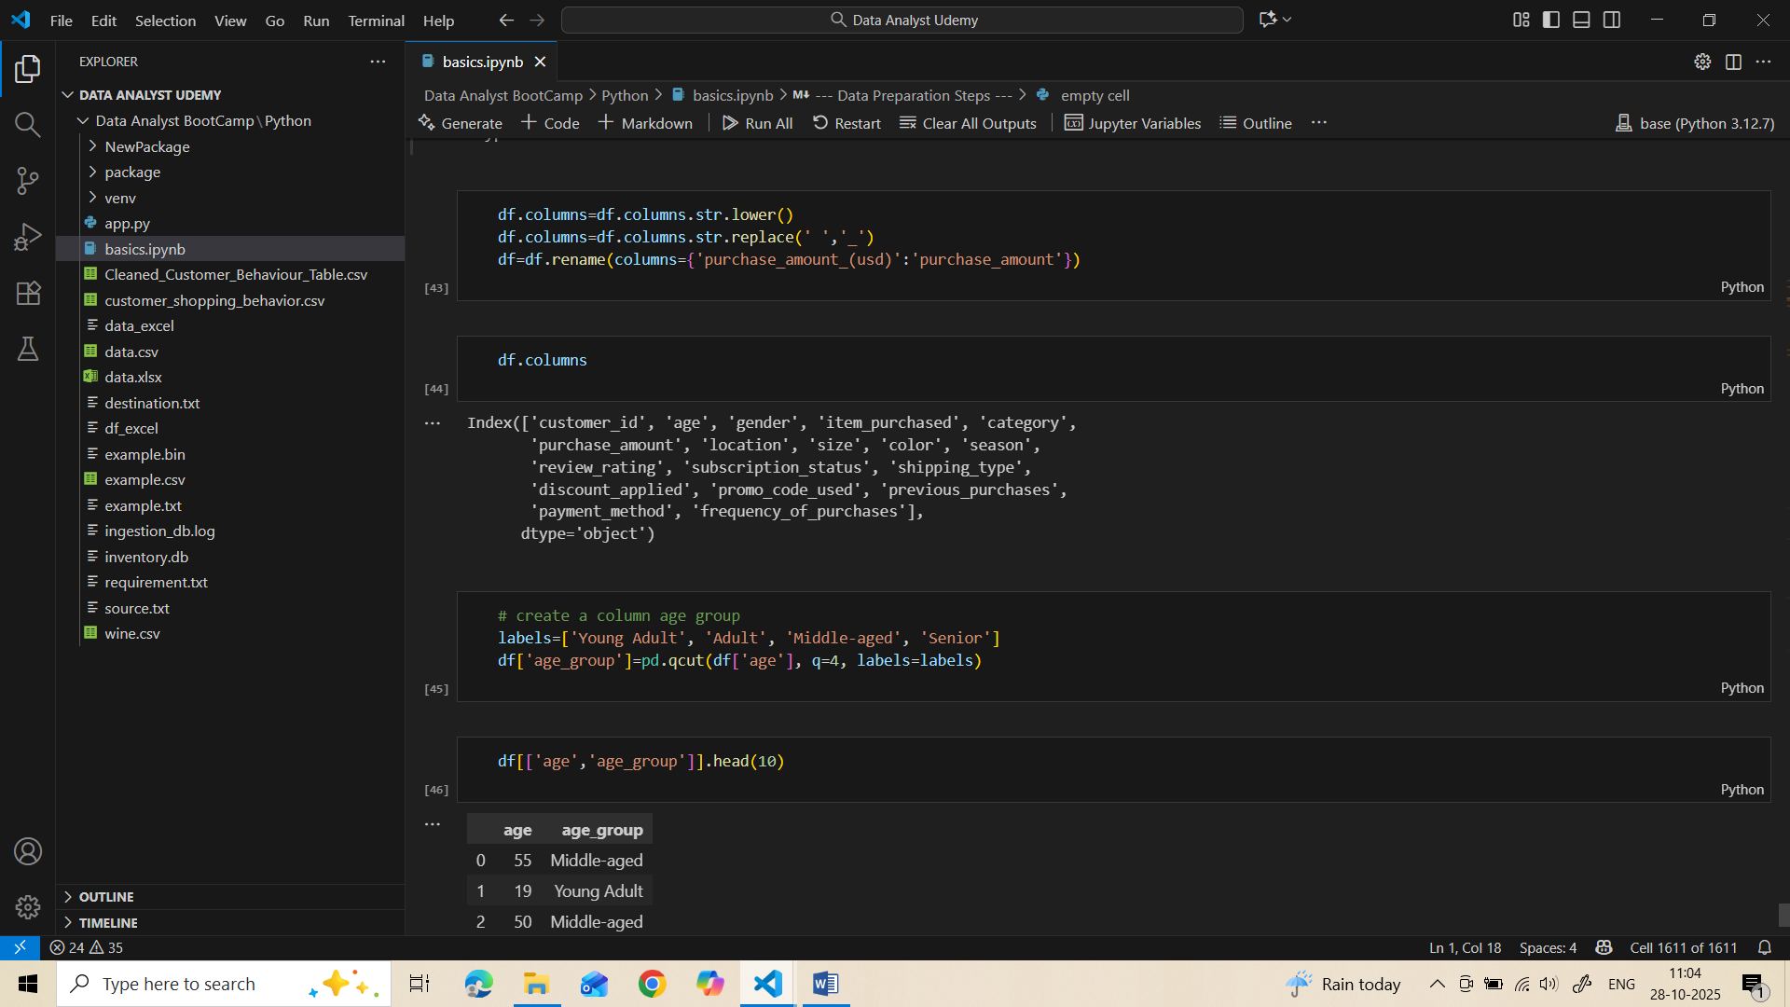

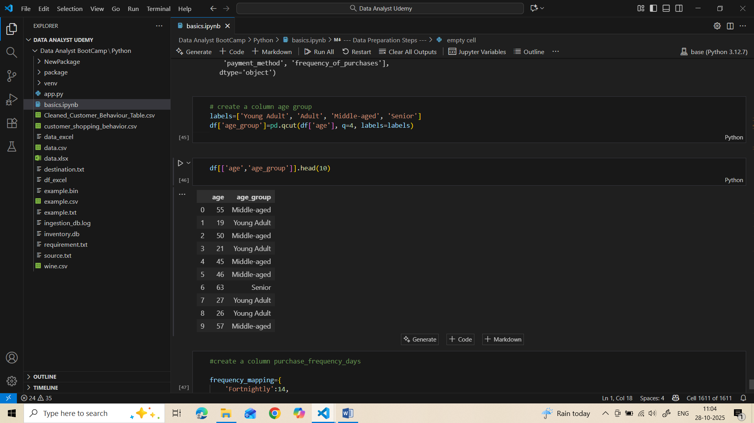

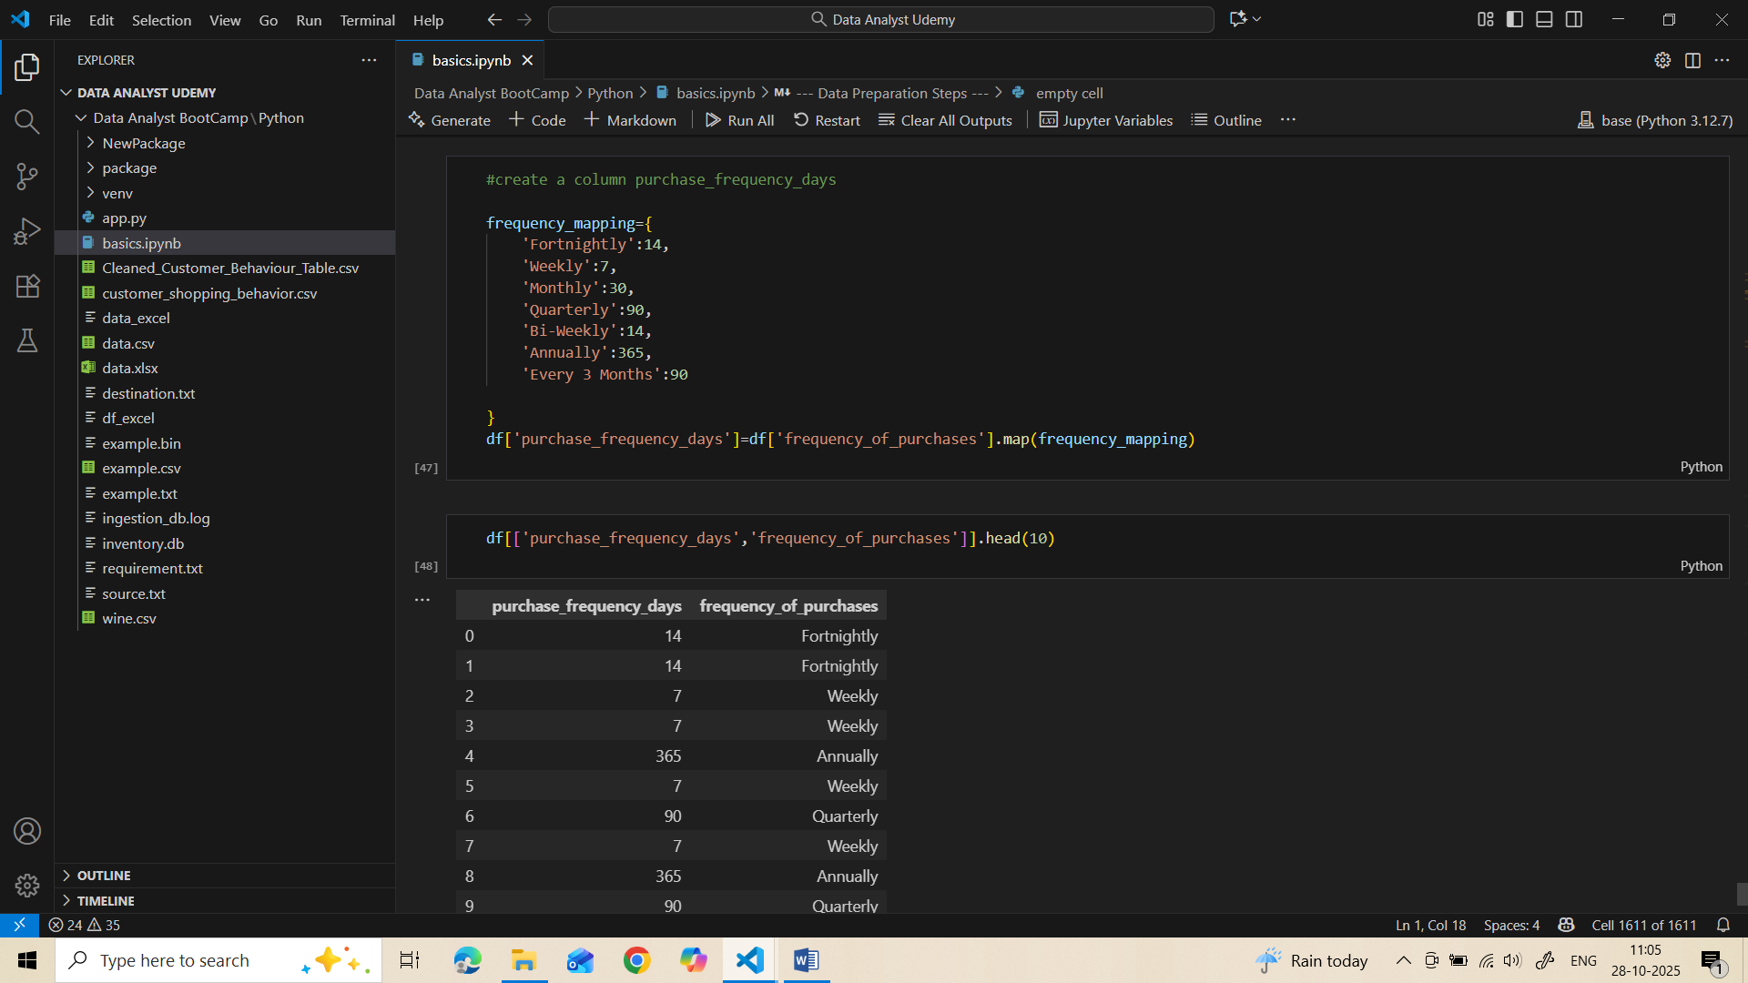

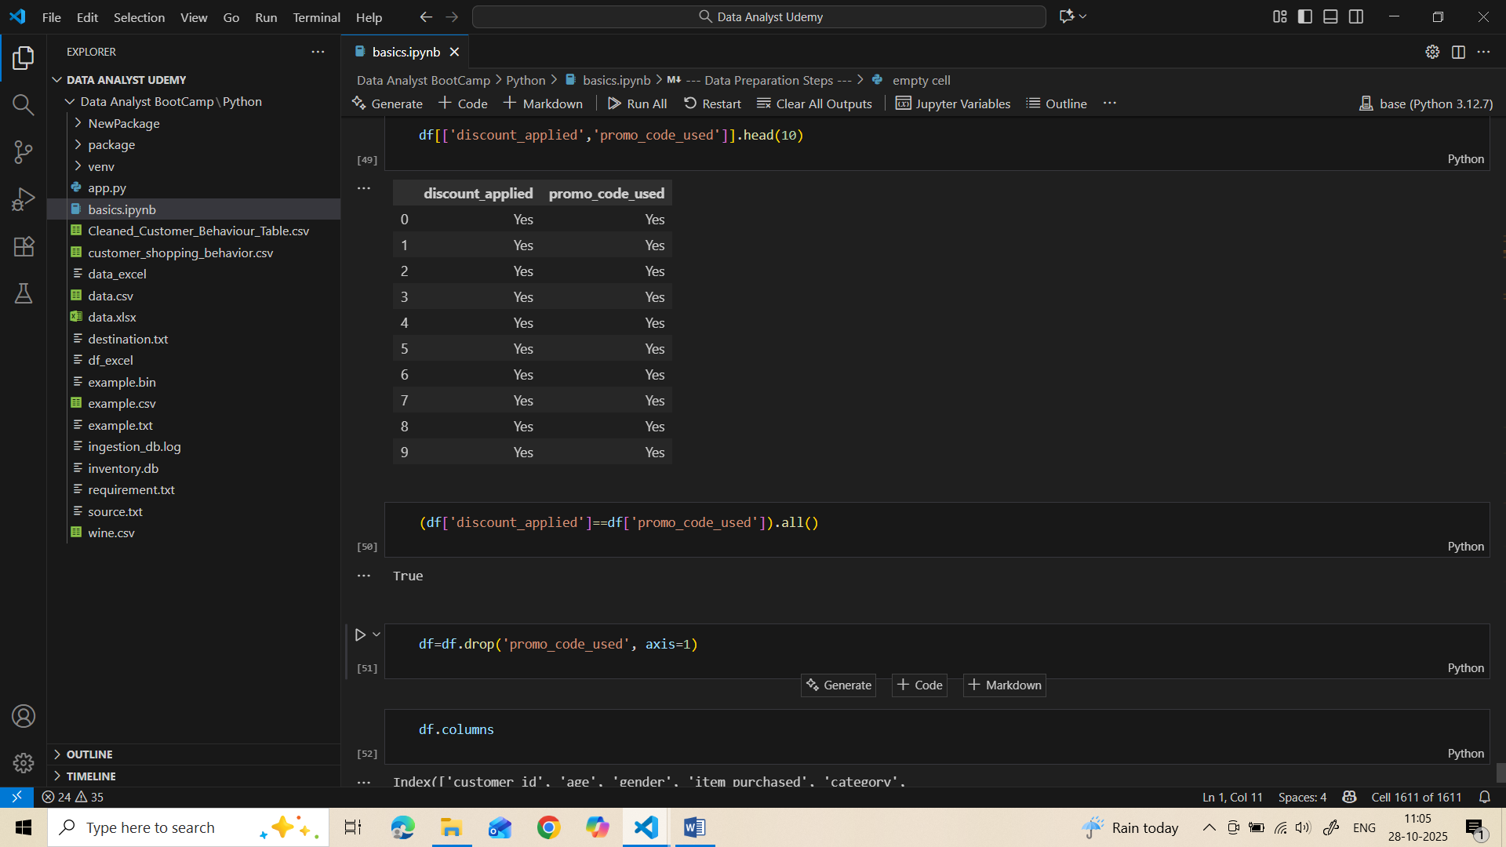

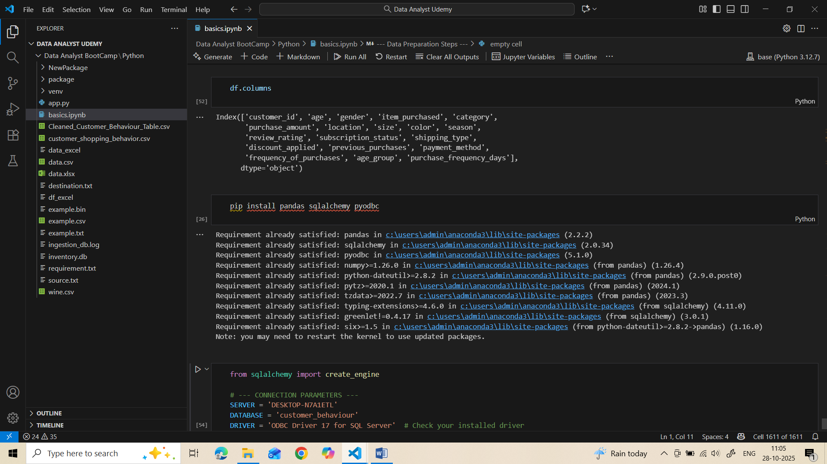

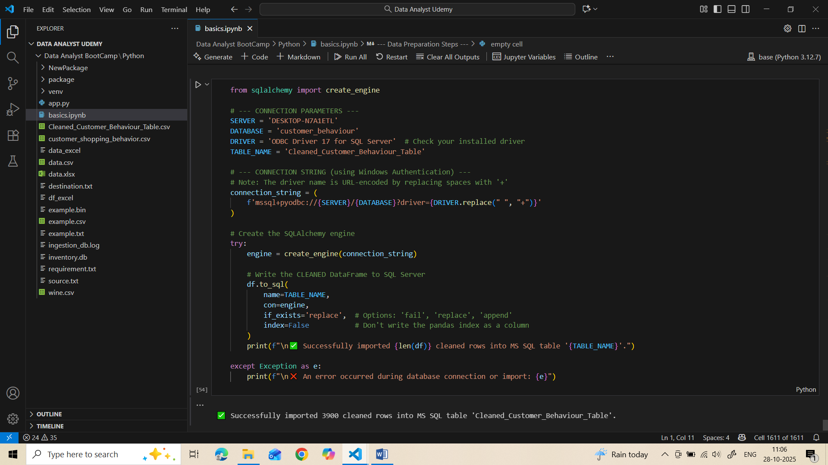

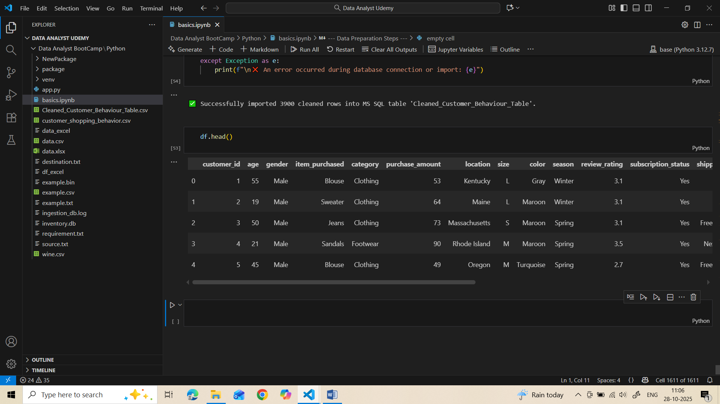

***SQL query generation***

